The basic HFT rested prone position
June 10, 2011 | Author Brian Samson
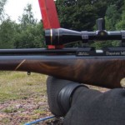
As you gain more experience in HFT you’ll quickly realise that it’s not just about being able to clamp your rifle onto a shooting ‘peg’ with your hand, rest the butt of your rifle on the floor and take a nice perfectly stable shot. To outsiders to the sport, this can often seem like it’s the case and that’s probably why HFT had difficulty establishing credibility with the rest of the shooting community in it’s early years.
A good HFT course setter will pay as much attention to the location of the shooting ‘peg’ as they will to the location of the target itself. On a typical HFT course you may only find half a dozen targets where it’s possible to use the basic rested prone position, or for the more cunning course setters, you’ll find that by adopting the basic prone position for a target will add substantial risk to the shot.
The existence of the basic prone position is also one of the reasons why HFT has become so popular. It’s very easy to learn, and it’s very stable when you follow a few simple principles and for that reason it’s easy for newcomers to be able to attain a reasonable score at their first event, so long as they’ve spent a little bit of time setting up their rifle and learning their holdovers.
Target shooting gloves
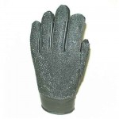
Target shooting glove from Olympic Marksmen Equipment eBay shop
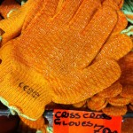
I found these for just 79p in a local shop this morning.
If you don’t already own one, they’re a very good investment for HFT. You can do without one for the basic prone position, but not having one will limit your options for other more advanced prone positions. They also help with kneeling and standing shots not to mention providing protection for your hand from sharp rocks and thistles etc. The glove I use only cost £11 including postage from Canada, the price has gone up a little since I bought mine but you can still pick the same glove up for around £20 including postage from The Olympic Marksmen Equipment eBay shop
If you don’t have a target shooting glove, a cheap gardening glove will do to start with. Look for something that has a decent amount of padding and is made from a non-slip fabric.
Enough already, tell me about the basic prone position!
Ok, I will soon but before I do, I’d just like to point out a couple of principals that apply to every shooting position.
The most stable positions rely on bone structure, not muscles to support the position.
You can (and should) hold your breath when taking a shot, but you can’t stop your heart beating and you can’t stop your pulse.
So for the basic rested prone shot, you must adopt a position that uses only your bone structure for support and avoids contact with the rifle or the ground with any part of your body that might impart a pulse ‘tick’.
There are two main parts of your body that will impart a pulse tick to the rifle – your chest and the hand that supports the fore end of your rifle. A well padded shooting glove will help to reduce (or eliminate) the effect of a pulse tick through your hand and a well placed elbow and knee will help to lift your chest and stomach off the ground.
The basic rested HFT prone position
Start on a level piece of soft ground, preferably with some grass on it.
Grip the base of a shooting peg (which is essentially just a 2×2 wooden stake driven into the ground firmly so that about 12” remains above the surface) and rest the fore end of your rifle on your hand. Rest the butt of the rifle on the ground.
You might want to experiment with different hand positions until you find one that’s rock solid with little chance of the rifle slipping off of your hand just as you’re about to take your shot (a surprisingly common cause of missed targets).
You might also want to experiment with resting your rifle on different sides of the peg until you find a position that feels comfortable and stable.
Lay down so that the butt of the rifle is under your armpit, it doesn’t need to be positioned into your shoulder. The most important thing is finding a position where you can get a clear and repeatable head position behind the scope.
If you’re right handed, rest your upper body weight on your right elbow and then bring your right knee up to support your lower body weight bringing your chest and stomach off the ground slightly.
Your body shouldn’t be directly in line with your rifle, it should be angled away by roughly 15-20 degrees. There’s no need to go searching for a protractor out of your old school pencil case, just remember that you should be to the side a bit – how much to the side is going to come down what feels the most comfortable for you.
If you’ve got the position right, the rifle should be rock steady. In fact if you line up on a target, you should be able to lift your head slightly so that you’re no longer looking through the scope, pull the trigger and still knock the target over without even looking. That’s not something I’d recommend doing in a competition, but it’s a fun party trick if that’s the sort of parties you go to.
And that’s it! – the only way you can muck the position up is by gripping the pistol grip of your rifle too tightly when you take your shot or getting your trigger technique and breathing control wrong.
They say a picture paints a thousand words, so here’s a few thousand words to help explain…

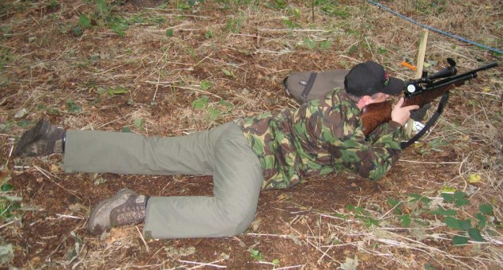
This isn't quite the standard rested prone position because the rifle butt isn't touching the ground.
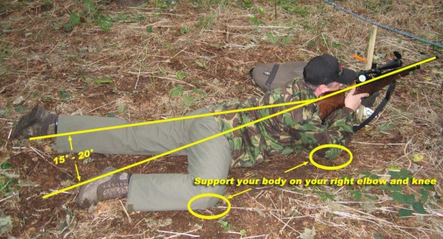
and here's the same position explained
Give yourself a good few hundred pellets in this position until you’re sure you’ve perfected it.
Now is a good time to start work on a ‘routine’ – and by that I don’t mean start work on a 15 minute open mike comedy spot, although that wouldn’t be out of place at most HFT events, it won’t help you to knock over any targets.
By a routine, I mean a shooting routine. Having a routine of things you always do for every single shot will help to increase your scores especially when you first start shooting competitions. Listen to the tales of woe you always hear around the burger van at the end of a competition. At any given competition, if you wait by the burger van long enough you’ll always hear of at least one person who scored a big fat zero (also known as a doughnut) on a target because they forgot to load a pellet or they forgot to fully close the bolt, forgot to take the safety off, forgot to cycle their magazine fed rifle… etc, etc. You’d be surprised at the number of things you have to remember to do before you take your shot.
There’s also a serious safety reason for having a set routine too. It’s not easy to load your rifle while you’re laying on your stomach in a muddy field somewhere, so you might find it easier to load it just before you get down for your shot. Please be extremely careful when you have a loaded rifle in your hands and you’re trying to get into a comfortable prone position. At best you risk accidentally touching the trigger as you’re getting into position and being awarded a doughnut (not the delicious variety) for your lack of concentration. At worst you risk waving a loaded gun back toward the shooting line and endangering everyone around you!. That behaviour is looked on very seriously and you will be asked to pack up your rifle and leave the competition immediately if you’re seen doing it.
The routine you come up with is going to be personal to you and will also depend on the specifics of your rifle.
I use a Steyr LG100 as my competition rifle. It doesn’t have a safety catch, and you have to load the pellet directly into the barrel with your finger. The good thing about this is that I can always see if I have loaded a pellet with a quick glance. If I don’t fully close the cocking lever, the rifle won’t fire or release any air, it just makes a metallic click when I pull the trigger. So my routine is to load a pellet into the barrel when I’m on my knees and just about to get into my prone position. I’ll then close the cocking lever, but not fully. Whilst always keeping the rifle pointed over the shooting line, I’ll get into position, make all of my final checks for range, holdover etc. Then close the cocking lever fully and take my shot.
A common mistake is forgetting to close your bolt resulting in a loud pop when you pull the trigger. In HFT you are classed as having taken a shot either when a pellet leaves the barrel or air is discharged from you rifle. So if you don’t load a pellet or you don’t close your bolt and your rifle goes ‘pop’ when you pull the trigger you’ll be scored zero for that target. It might seem like a harsh rule, but if you do it once, you’ll be so annoyed with yourself, you’ll probably never do it again.
Another common mistake is either not loading a pellet, or double loading two pellets. If you’re not sure whether you’ve loaded a pellet when you’re about to take a shot, it’s ok to test fire your rifle into the ground so long as you clearly let the other shooters in your party know that you’re going to ‘put one in the ground’ beforehand.
I’m also careful to always keep my rifle pointing down range all of the time while I’m getting back up from my shot. Although my gun is no longer loaded, other shooters don’t know for certain that it isn’t and certainly won’t appreciate looking down the end of my barrel as I wave my gun around getting up from a shot.
So.. while you’re practicing the basic HFT prone position, also practice getting up and back down into position. Don’t just get into a comfortable position and carry on shooting until you run out of air or pellets. Practice approaching the peg as you would in a competition, loading your rifle and getting into position, then getting back up again safely.
Once you’ve perfected the prone position, set up your scope and practiced your breathing and trigger control you should be able to shoot single hole groups at 25 yards. You’ll then be ready to start zeroing your rifle for your first HFT competition.
And that’s the subject of the next article in this series.

